CHAPTER NO 13

MANAGING FILES AND
FOLDERS IN WINDOWS

WHAT ARE FILES?
Our computer network is like a huge filing cabinet that stores all our compute information. Each drive is like a separate drawer in the cabinet. A file is a single “document” that is saved to a drawer that means in diskette, USB, hard drive or any other storage device.

Each letter, slide show, spreadsheet, or database you create is stored as a file. Every file saved has a filename. You can use multiple words for the filename; for example, Letter to Sam. Do NOT use special characters, \ / : * ? " < > | .
Every file also has a three-letter extension, assigned by the Windows system that associates it with a specific program. For example, a WordPerfect complete file name would be "Letter to Sam.wpd" and a Word file name would be "Letter to Sam.doc".

WHAT ARE FOLDERS?
"Folders," also known as "directories," on your computer work in much the same way that file folders in the real world work. Folders are used to organize the data stored on your drives. The files that make up a program are stored together in their own set of folders.

FILE STRUCTURE

The file structure is best described and understood in a tree structure format. A tree structure is one way of representing any hierarchical structure in a graphical form.

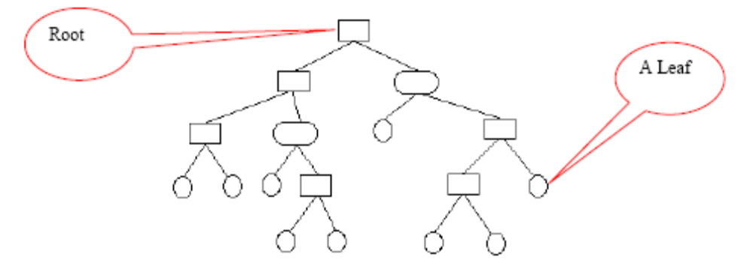

It is called a "tree structure" because the graph looks like an upside down tree meaning that the root of the tree is on the top and the leaves at the bottom.
Microsoft Windows uses the same structure and we all use it everyday at work, even though it may not look like the figure above. Our shared drive data structure looks like the following:
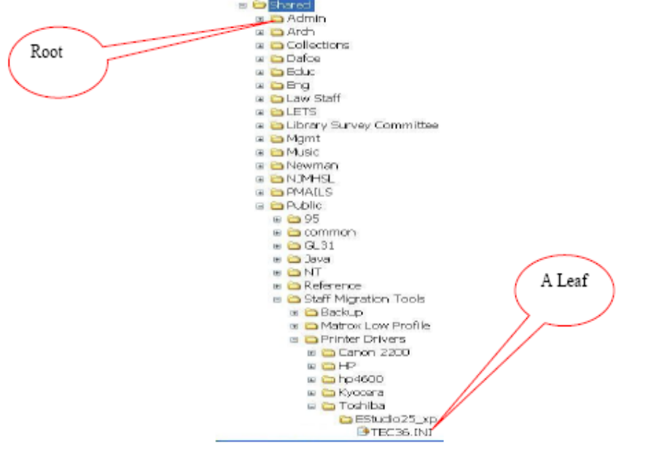

ORGANIZING FILES AND FOLDERS

As you can see in the previous example, the libraries shared drive is organized in a tree format. S:\ is the root and all other folders are contained inside it. Most departments have their own folders which is the root for their department. For example: UE examination department.

Here is another way to think about it. Just imagine a filing cabinet with many drawers. Inside the drawers are many folders and within the folders there are other folders or individual documents.

Notice the minus sign besides the shared folder. Whenever you see a minus sign beside a folder, it means the folder is fully expanded and does not contain anything else other than what is showing below it. A plus sign means that the folder contains at least one file or folder inside it. Clicking the plus sign will expand the folder and make known everything inside it.

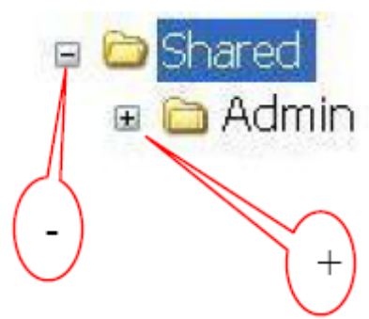

HOW TO CREATE A FOLDER
Here are the two most common ways of creating folders:

- In My Computer, double click on the folder where you would like to create a new folder.
- You can then create a new folder by selecting “Make a new folder” in the File and Folder
- Tasks drop-down menu. In the following example, a new folder will be created inside a previously created folder named “officework”.

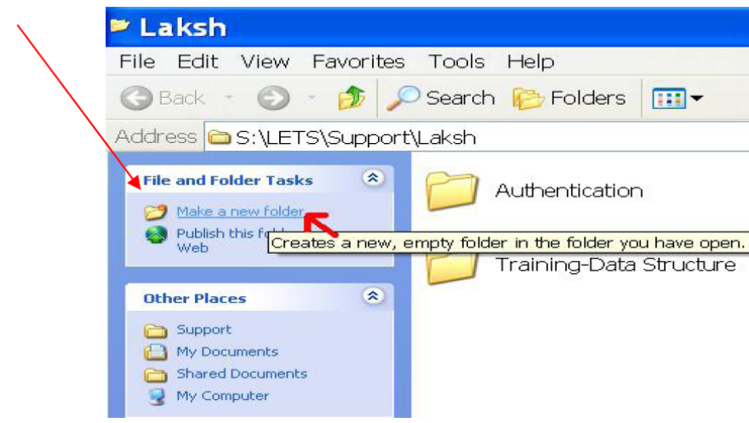

- A folder icon will appear. Please rename the folder with a descriptive name:


OR

- You can also create a new folder by right clicking on an empty space in your H:\My Documents folder and selecting New and then Folder (this is all still in My Computer).

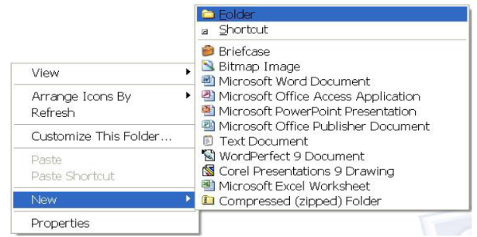

A folder icon will appear. Please rename the folder with a descriptive name:


NAMING A FILE

Definitions:
File: A file is a single “document” that is saved to a diskette, USB, hard drive or any other storage device.
Folder: A folder is where files are stored.
Path: A path is the line of folders you must follow to locate a specific file; it begins with the drive letter designation and includes the folders. For example, H:\data\reports\status.doc is a path with file named status.doc that is on the H: drive and is in the reports subfolder of the data folder.
All file systems follow the same general conventions: a base file name and an optional extension, separated by a period e.g. abc.doc.

MAXIMUM LENGTH

In Windows, the maximum length for a path is 255 characters including spaces, hyphens, underscore and any other character you use (no periods allowed). A path is structured in the following order: drive letter, colon, backslash, components separated by backslashes, for

Example:
H:\my documents\personal\trips-I-have-taken-in-the-past-few-years\I-have-onlytaken-
one-trip\i_need_to_go_travel_some-more\my-pictures\year- 2006\May\first_week\hiking-in-the-mountains\this-is-the-maximum-length-of-a-filename\ including-the-folders\LK.html.

Note: As you may have noticed above the actual file name is only two characters (not including the .html extension) but remember the maximum length for a file path is 255 characters, so depending on how many folders you have inside a folder where you are storing the file, the length of the actual file name will be restricted.

NAMING CONVENTIONS

Do not assume case sensitivity. Consider names such as OFFICE, office, and office to be the same.
Use a consistent method for file and folder naming.
Avoid too many folders inside a folder (remember the path length limit).

BROWSING FILES

Even when you know where a file is stored, sometimes there are so many files in the folder that it is difficult to find the file you want. The best way to search through a large folder is to use the “Details” view. The “Details” view allows you to quickly sort your files and view different types of information about all the files in a folder.

To use the Details view

- Open the folder you want to browse. In the example, I am in my “Pictures” folder.
- Click the “Views” button, and then click “Details”.
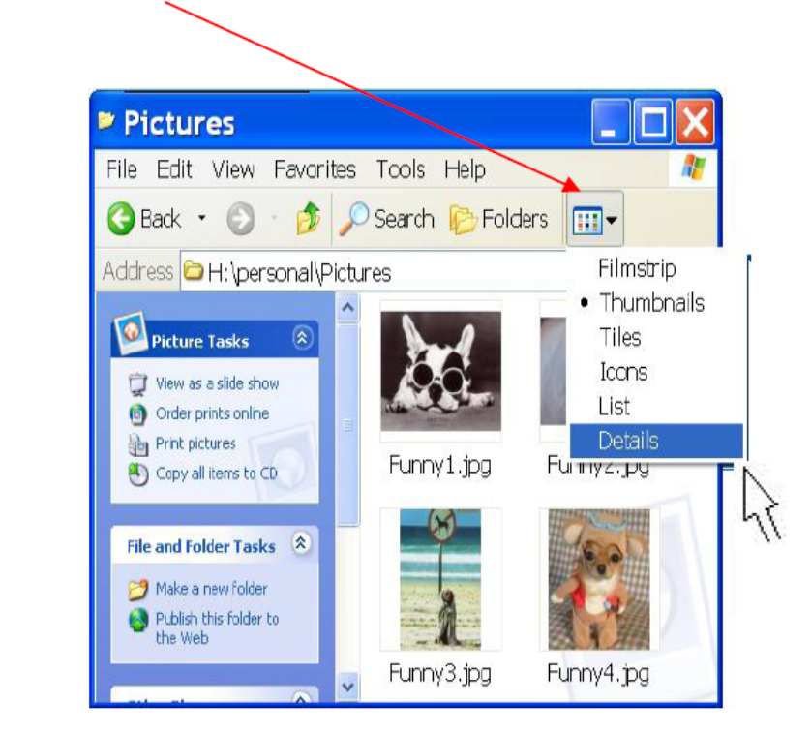

- Sometimes it is easier to find a file if all the files are sorted in a particular way. Suppose you created a file yesterday afternoon but do not remember what you named it.

- Click the column heading that you want to sort by. For example, to sort files from oldest to newest, click the “Date Modified” heading. To reverse the sort order (for example, to sort from newest to oldest), click the column heading twice.
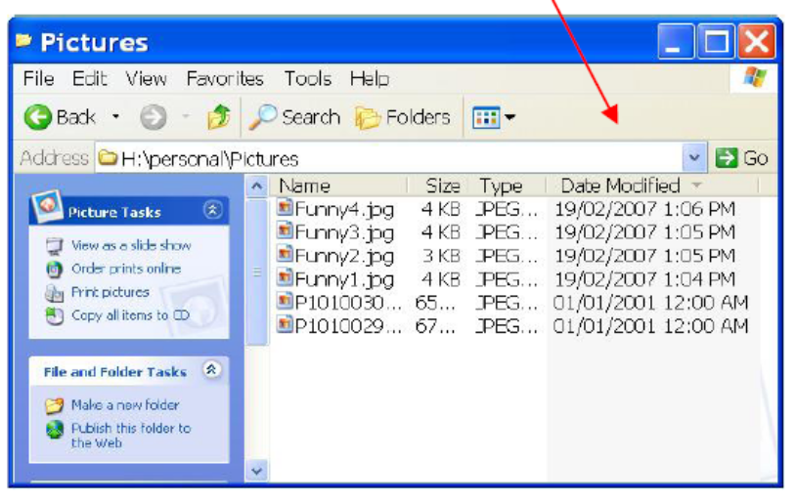

- By default, the “Details” view shows the file name, date, size, and type. You can add other information as well. To add or remove columns, right-click a column heading, and then click “More”.

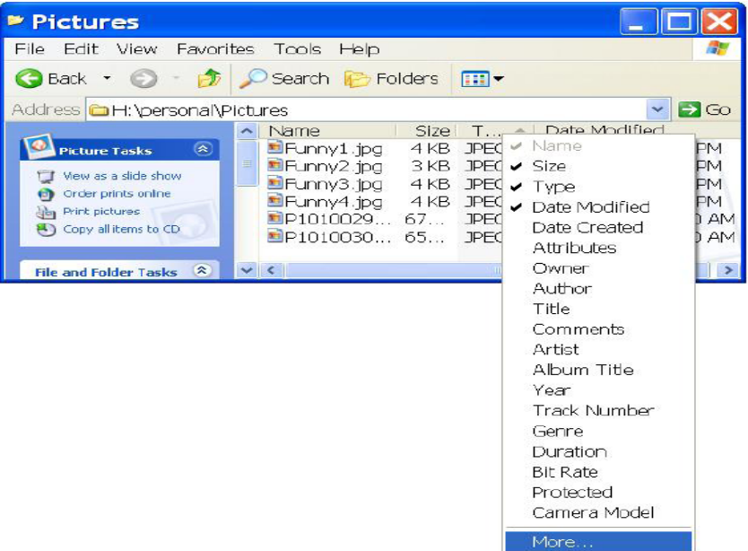

- In the Choose Details dialog box, select the columns you want to see in the Details view. For pictures and videos, you can add Dimensions to sort by size. For music, you can add Artist, Album Title, and Genre to make it easier to find the songs you want.
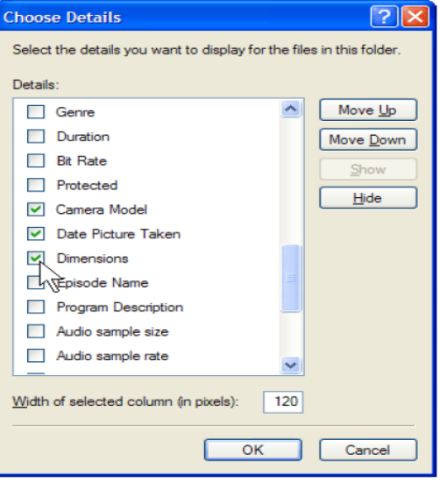

- Click “OK” to add the columns to your Details view.

- When you modify the columns in the Details view, it affects only the folder you are viewing.

MOVING FILES FROM ONE FOLDER TO ANOTHER

Sometimes you need to move files that you have already created into another location. It has two methods for exploring any document defined below:

METHOD 1

- Click “Start” “Programs” “Accessories” “Windows Explorer”.

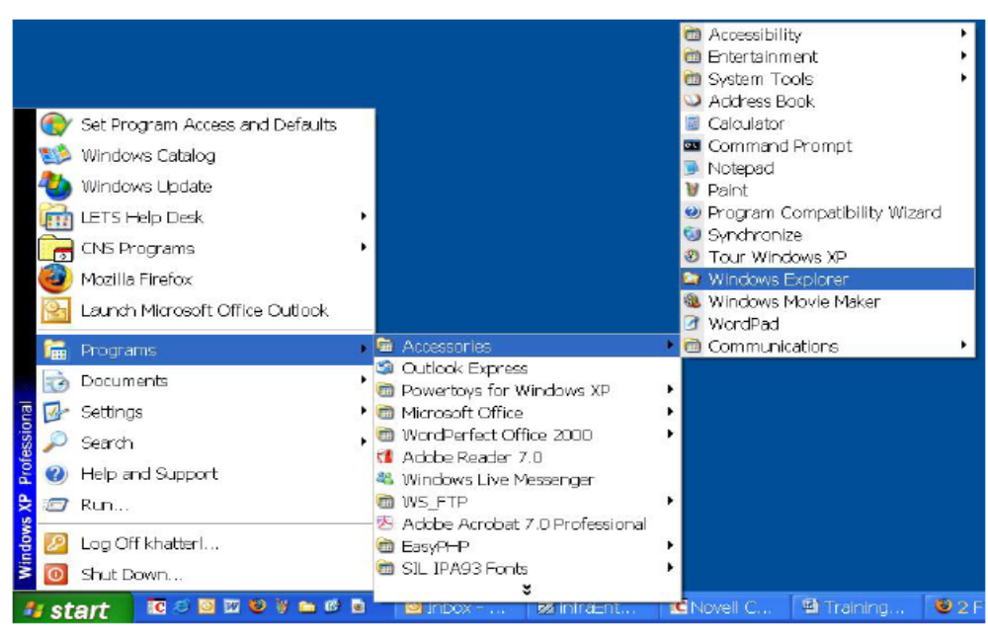

- In “Window Explorer”, locate and select the file or folder you need to move using the tips above.
- 3. Expand to the destination folder by clicking on the “+” sign if needed

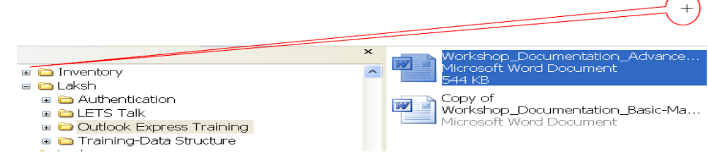
- Drag the file or folder to the destination and drop it in.

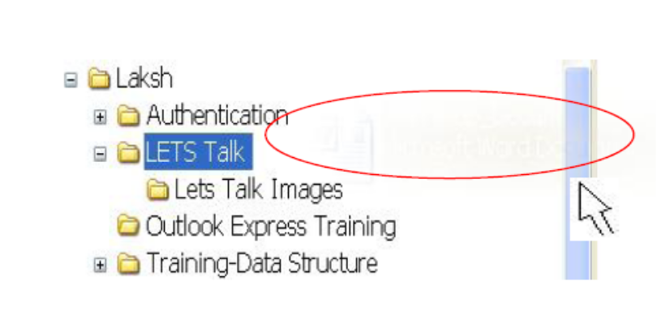

METHOD 2

- In “My Computer”, locate and select the file or folder you need to move using the tips above.
- Click “Edit” “Cut” or press Ctrl + x on the keyboard to cut the file.
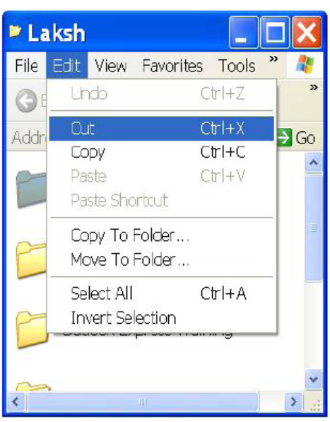

- Open the destination folder.

- Click “Edit” “Paste” or press Ctrl + v on the keyboard to paste the file.
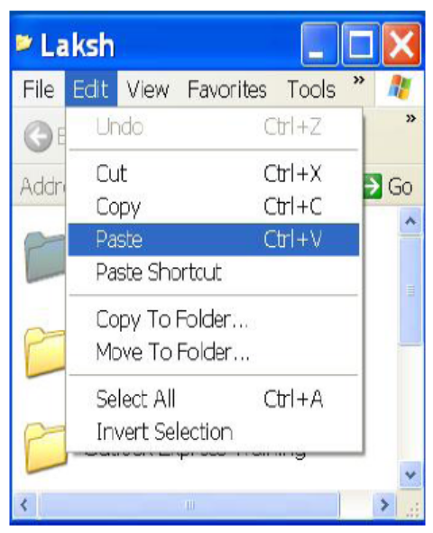

OPENING FILES

Sometimes you open up Microsoft Word and click “File” “Open” and pick the file you want to open and you get the following error message:
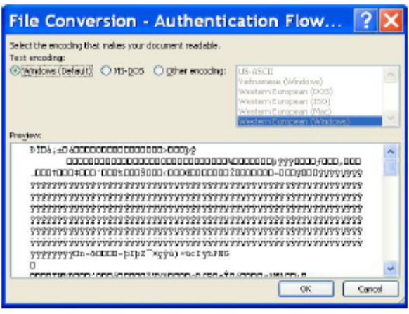

This happens because you are trying to open a file in Microsoft Word that is not a “Word” file
(.doc) but rather in some other format such as power point (.jpg, .ppt, .pdf ), etc.
Another way to open a file is by navigating to the file in “My Computer” and then double clicking on the file. The file will automatically open in the appropriate program whether it is
Microsoft Word or PowerPoint.

HOW TO CREATE SHORTCUTS?

Shortcuts can make your life easier or harder depending on how you use them. By creating too many shortcuts you will clutter up your desktop. A shortcut is just a reference link on your desktop to a file or a program.

Example:
You could create a shortcut on your desktop of a file saved on your H:\ drive that you access everyday or quite frequently. This way your file stays on the H:\ drive but you create a link to the file by creating a shortcut. This allows you easy access to the file without compromising the file in case of hard drive failure.

Note: Copying or saving a file to your desktop is not the same thing as creating a shortcut. When you copy a file to the desktop, you actually make a duplicate copy of the original. This means you have two files now, one on the desktop and another in the original location. Making any changes to one of the files will not change the other.

CREATING SHORTCUTS:

Here is one way to create shortcuts:

- Click on Start Programs Accessories Windows Explorer.
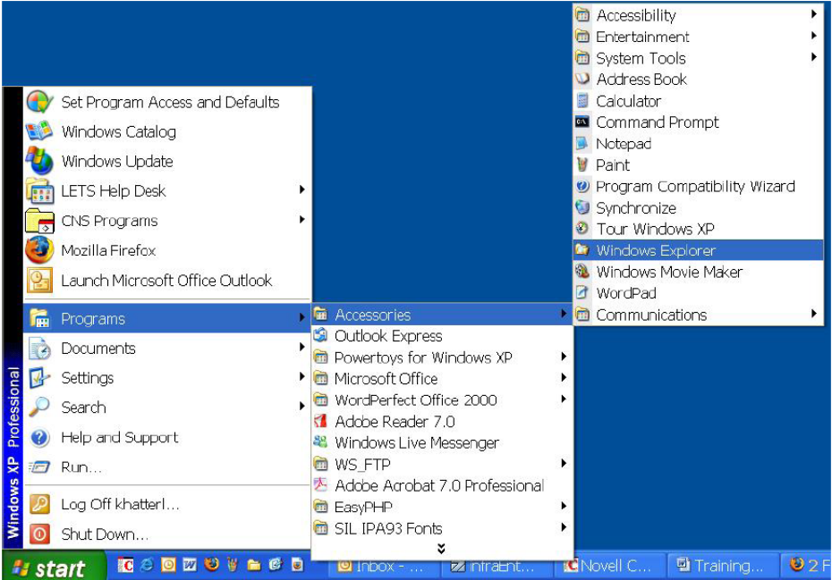

- Find the file or program you want to create a shortcut for.

- Right click on the file, then click on “Send to” and then click “Desktop (create shortcut)”
- You should now see a shortcut icon on your desktop.

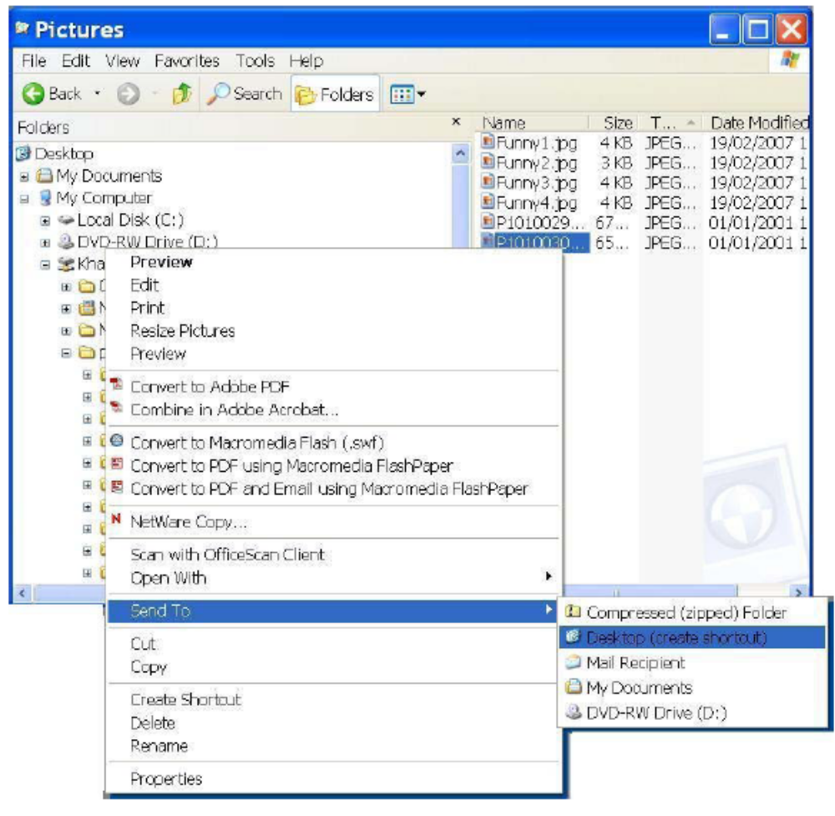
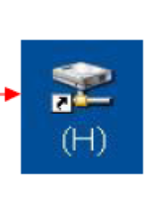
NOTE: A black arrow on the icon means that it is a shortcut. Otherwise, it may be a copy of the file.

